Norse Trade Partners

April 15th, 2026
Schedule Change – LAX Flights suspension S26 Season.
I’m writing to inform you of an important decision regarding our scheduled operation to and from Los Angeles summer 2026.

Due to the continued increase in fuel constraint risks, fuel prices, and the resulting impact on our operating costs, we have had to make the difficult decision to suspend our LAX operations this summer, May – October.

All affected customers will be proactively notified by Norse Atlantic Airways today where contact details are available.

While we have taken all possible steps to inform impacted passengers, we anticipate increased enquiries from agents and customers, and we appreciate your continued support in managing these interactions.

We sincerely apologize, but as a consequence of this fuel crisis, it is our responsibility to ensure we make this decision to maintain a sustainable airline for our passengers and colleagues.

This was not an easy choice, as we truly value the partnership we’ve built with you.

Yours Sincerely,

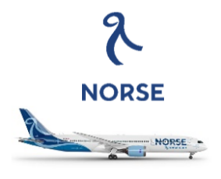 | Andrew Fish  Head of Sales  Norse Atlantic Airways

